Credit Name: CSE3010 - Computer Science 3
Assignment Name: LocalBank

What error messages did you encounter (if any)?

- The program was trying to index 0 of a string, but the string didn’t have any characters in it and therefore had no index 0.

What unexpected behavior did your program exhibit?
- Because of the position where the variables were defined, the code wasn’t grabbing the updated text. When the empty variable was sent to the other classes, it had an index of 0, and the other methods couldn’t obtain the position of a letter because it didn’t exist.

What caused the issue (e.g. syntax error, logic error, incorrect function usage, etc…)?

- Logic error. The positioning of certain lines of code

Include a screenshot of specific lines of code.
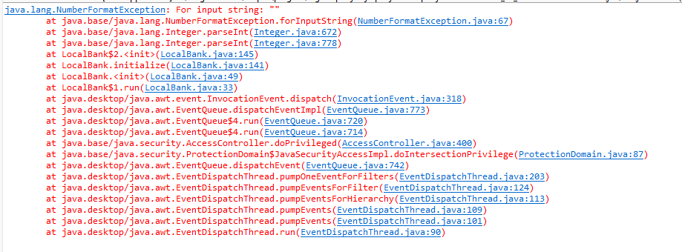

How did you fix the issue?

- I moved the position of the line of code that defined the variable and put it in the action event so that it grabbed the new inputted text every time the button was pushed

Provide the corrected code or solution using a screenshot.

